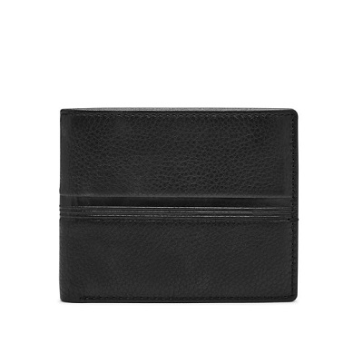

ROGER FLIP ID BIFOLD

PRODUCT DETAILS

**Silhouette: Bifold with Flip ID**

**Exterior Material: Leather**

**Interior Details: 1 Bill Compartment, 6 Credit Card Slots, 2 Slide Pockets, 2 ID Windows**

**Measurements: 4.5"L x 0.75"W x 3.5"H**

**Warranty: 1 Year Limited**